NAME CTA_z SDSS_z lmfit
IES 0505 ? (BL) 0.0001 (STAR) 0.7650(PL+gal)
SUMSS J082627 0.3397 0.94 (Galaxy) 0.1851 (PL+QSO)
PMN J2221 ?(BL) -0.004(STAR) 0.1328(PL+Galaxy)
RBS 1424 0.2265(BL) 0.001 (STAR) 0.0253 or 0.5 to 0.6
NVS J152048 > 0.864 0.3176 (Galaxy) 0.3286 (PL+Gal
GB6 J0045+2127. 0.2544 0.4225 (Galaxy ) 0.4225(PL+Gal)
NVSS J15151148 >0.449 0.0026 (STAR) 0.57507(PL+Gal)
PMN J2321 0.8126 0.2908 (Gal) 1.8205 (Pl+QSO)
PMN J1042 0558 0.3925 0.8612 (Gal) 0.3921 (PL+Gal)
GB6 J0223 0.5943 (Gal) 0.4444(PL+Gal)
FRBA J0054 ? 0.5383(Gal) 0.0100(PL)
SUMSS J031614 0.6161 0.0027 (Star) 0.0769 (PL+Gal)

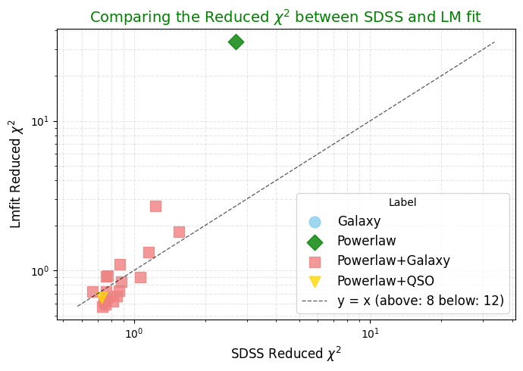

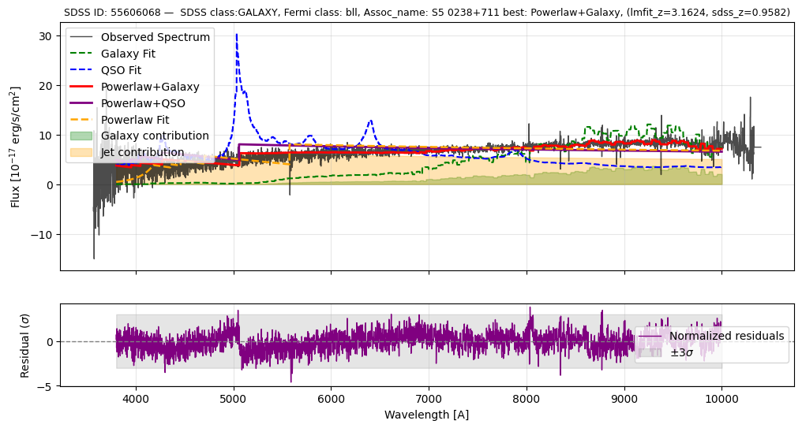 0.92 (lmfit), 0.772(sdss)

